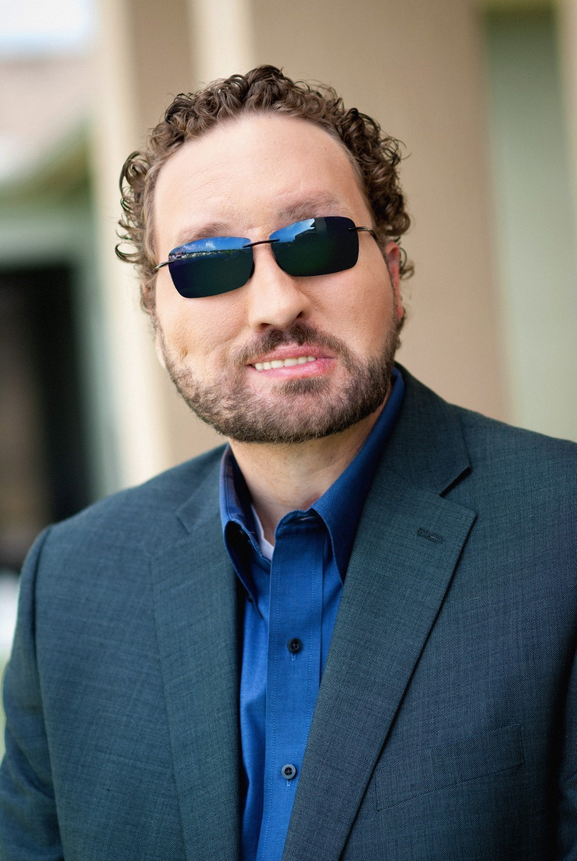
Missouri Mid-South Conference
High School Youth Event (CYE) 2020
“Embracing Our Stories”
February 15-17, 2020 at Camp MoVal
Featuring Keynote Speaker and Workshop Leader Marcus Engel

Registration information can be found at www.mmsuccyouth.org
and in the MMS Conference e-Courier.
Registration deadline: January 24, 2020.
Cost: $140
For more information, contact
Cindy Birkner cindy@mmsucc.org

Marcus Engel grew up in High Hill, Missouri and spent his youth attending Missouri Mid-South Conference events, youth activities, and camping at MoVal. Marcus grew up attending the Conference Youth Event every year. His life was changed his Freshman year of college when a sudden car accident impacted his life forever.
Marcus speaks from experience. It’s not theory, it’s not academic, it’s reality. It’s a journey that isn’t always pretty, but one that helps health care professionals understand their vital role in a patient’s experience. Marcus holds a B.S. in sociology from Missouri State University and a Master’s Degree in Narrative Medicine from Columbia University. He has authored four books which are being used by scores of nursing schools and allied health care programs to teach strategies for excellent patient care. Marcus and his wife,
Marvelyne, are the co-founders of the “I’m Here” Movement, a 501(c)3 non for profit changing the culture of care through two simple words. He lives in Orlando, Florida with Marvelyne, and his Seeing Eye dog, Elliott.

Conference Youth Event 2020
(Sponsored by the Missouri Mid-South Conference of the United Church of Christ)

INFORMATION PACKET

PARTICIPATION
Youth: Currently in grades 9-12. Advisors:
Adults, age 21 and older
An overall minimum of 1 adult advisor is required for each 8 or fewer youth participants. Churches are also responsible for providing male and female advisors in proportion to the male/female break-down of their group. There should be one female advisor for each 1-8 female participants and one male advisor for each 1-8 male participants. This requirement ensures adequate supervision in sleeping areas. If your church is having a difficult time with this requirement, consider teaming up with other churches in your area to meet this ratio. If you are still having difficulties with this, contact Cindy Birkner or Jeremy Force.

DATES & LOCATION February 15-17, 2020 at Camp MoVal in Union, MO

ARRIVAL & DEPARTURE
Check-In: Saturday, February 16 at 9:30am
Departure: Monday, February 18 at 11:30am

CONTACTS & IMPORTANT PHONE NUMBERS
Before the event:
Program Rick Oberle 573-241-2027 (Rick’s cell number)
Cindy Birkner 313-575-1951 (Cindy’s cell number)
Registration: Jeremy Force 636-583-2730
During the event: Jeremy Force 636-583-2730 (camp office) 610-823-5552 (Jeremy’s cell number)

During the event, please use these numbers only in case of an emergency. Advisors and participants will be actively out and about involved in the program during most of the day and evening.

$ COST $
The registration fee is $140 per person for each youth and adult participant. You are not registered until ALL of your forms and complete payment is submitted. Registrations must be received at the MoVal office by Jan. 24th to ensure space availability and t-shirt. We cannot guarantee a t-shirt if you register after the deadline.

HOUSING
Participants and advisors will be housed in cabins by church group. Smaller groups will be combined within cabins. It is each church’s responsibility to ensure adequate male and female supervision overall and in the living units. FYI - Most cabins have 7 double bunks and a restroom with two toilets, two showers and two sinks. These cabins hold up to 12 youth and 2 leaders.

COVENANTS
There is a covenant for youth and a separate covenant for adults. Please take the time to review these carefully. All participants, youth and adult, will be expected to abide by these. Please return a signed copy of the appropriate Covenant for each youth and adult with the registration materials.

HEALTH CONCERNS
Local church advisors are responsible for first aid and health issues for their participants. Advisors should carry a copy of the Registration & Health Form for each adult and youth participant. They should also come prepared with first aid supplies. In case of an emergency the camp will provide back-up supplies and support. It is the responsibility of the family and/or each local church to provide health and accident coverage for their advisors and participants. Following camp procedures, medications will be kept secure and adult advisors can access them to dispense to youth when needed.

REGISTRATION
Remember registration is by CHURCH GROUP, not by individual. * If you need help matching a youth to a church group, contact Cindy or Jeremy.
A Registration & Health Form and a Signed Covenant is required for each youth and adult. Advisors should keep a copy of these forms with them while at camp and during transportation, in case of an emergency. Mail these fully completed forms, payment, and the Group Registration Form.
Make Checks Payable to: Send Registration Forms & Payment to:
REGISTRAR - YOUTH EVENTS
CAMP MOVAL ROAD UNION, MO 63084

MMS-UCC

All forms are due to the MoVal office by January 24th 2020.
You are not fully registered until all forms and payment have been received.

ADULT LEADERSHIP
ALL adults must complete a Disclosure Statement and a Background Check Form. There are no exceptions. Adults that do not turn these in before the event, will not be allowed to attend.
There will be no refunds on the registration fee is an adult fails to complete these forms. The Missouri Mid-South Conference takes the safety of children and youth very seriously. These are two easy precautions that are mandatory to ensure the safety of all those attending the event. Your cooperation with this is appreciated. If you have questions about this procedure, contact Jeremy Force through Camp MoVal.

POLICY ON TOBACCO PRODUCTS, DRUGS & ALCOHOL
The use of tobacco products is not allowed on Camp Mo-Val property. There is no smoking/vaping/juuling in any buildings at Camp Mo-Val, or in the woods.
The use of alcohol and/or illicit drugs will not be allowed at any Conference youth event or retreat, with no exceptions. This includes every participant and leader, youth and adult. Such activity is destructive to the spirit of Christian community we hope to build at all our youth events. Use of alcohol and/or illicit drugs will result in the offending parties being sent home AT THEIR OWN EXPENSE.

THINGS NOT TO BRING
Please DO NOT bring expensive or valuable items, technology (hand held games, tablets, etc), illicit drugs, alcohol, tobacco products, skate boards, fireworks, weapons (including knives), or other items that may be considered harmful, dangerous or distracting to the program. The Missouri Mid-South Conference and Camp MoVal are not responsible for the loss, damage or theft of property.

CLOTHING & EQUIPMENT LIST
_____ Comfortable, warm clothes and shoes
_____ PJs, Sleeping bag, Pillow, twin sheet to cover mattress
_____ Wash kit (soap, shampoo, toothpaste, toothbrush, deodorant, etc.)
_____ Towel and Wash Cloth
_____ Bible
_____ Any extra $$ needed for the trip to and from the retreat
_____ Any necessary medication
(Please be sure that the home church advisor is aware of any medications to be taken and any special medical considerations. All medication must be sent in its original packaging with appropriate dosing information. All medications will be safely stored and adult advisors will be allowed to access them when needed)

CONFERENCE YOUTH EVENT 2020
Youth & Adult Registration & Health Form (Please Print or Type in Ink)
Sponsoring Church
Name of
Participant / Advisor (Last) ________ (First)_________________________
Date of Birth Age as of FEB 2020 Grade Gender
Mailing Address E-mail __________________________________
City State Zip Code

Parent / Guardian #1 or Adult Advisor __________________________ ______________
Home Phone ( ) Cell Phone ( )___________________________
Email _________________________________________
Parent / Guardian #2 ___________________________________________
Home Phone ( ) ______ Cell Phone ( ) ______ __ __________
Email _________________________________________
T-shirt (Choose one ADULT size): SM____ MED____ LG____ XL____ XXL____ (Included in Fee) EMERGENCY CONTACTS (if parents/guardians CANNOT be reached):
NAME ________Day Phone ( )______________________________
Relationship _________ Evening Phone ( )__________________________
NAME _________Day Phone ( )______________________________ Relationship ________Evening Phone ( )___________________________
PARENT/GUARDIAN AGREEMENTS & AUTHORIZATIONS:
(To be completed for all Youth Participants)
- The Participant named above has my permission to attend the Conference Middle School Event, which is sponsored by the Missouri Mid-South Conference of the United Church of Christ, and is being held at Camp MoVal in Union, Missouri, February 15-17, 2020.
- We (participant and parent) understand and support policies prohibiting campers from using or possessing weapons, tobacco products, alcoholic beverages or non-prescribed drugs during this event. We recognize that participants must follow safety guidelines and refrain from harmful behavior. We understand that if a participant is unable to live within these guidelines and those outlined in the Covenant, he/she may be sent home without a refund of the program fee.
- I understand that the participant may be photographed or electronically recorded for future Missouri Mid-South Conference UCC program information and promotion.

SIGNATURE OF PARENT/GUARDIAN_______________________________ DATE ___________

CONFERENCE YOUTH EVENT 2020
Youth & Adult Health Form (Please Print or Type in Ink)

Name of Participant / Advisor __________________________________________________
Name of Physician _______________ Phone ( )__________________________ Name of Dentist/Orthodontist ______________ Phone ( ) _______
Medical/Hospital Insurance: Carrier ________________________________________________
I.D. / Policy / Group# ______________________________________________________________ Special Instructions _________________________________________________________________ Dental Insurance: Carrier___________________________________________________________ I.D. / Policy / Group# ________________________________________________________________
Special Instructions__________________________________________________________________
Date of last Tetanus Shot Approximate Weight_________________

List any current medical conditions, allergies, or special dietary needs (be specific):

List any medications to be taken at the 2020 Retreat and specific times and dosages, and in the original bottle(s):

List any additional health information or activity limitations church advisors should be aware of (surgery or serious injuries, chronic or recurring illness/medical condition, psychiatric counseling or indications, recent traumas, life changes etc.):

PERMISSION TO PROVIDE NECESSARY TREATMENT OR EMERGENCY CARE: I request and authorize my church advisor, event coordinators, Missouri Mid-South Conference staff, and medical personnel & facilities selected by them to provide all medical care including but not limited to tests, such as pathology, radiology and anesthesia, surgery, and prescriptive drugs advisable for the health of the Participant / Advisor. I acknowledge that no representations, warranties or guarantees as to result or cures will be made.
SIGNATURE OF PARENT/GUARDIAN OR ADULT PARTICIPANT_____________________________

DATE SIGNATURE OF WITNESS _________________________________

CONFERENCE YOUTH EVENT 2020 YOUTH COVENANT

Because God calls us to be a community of faith and leaders in Christ's church, I covenant with God and with the other participants to conduct our life together at the Conference Middle School Event in a manner that promotes a healthy community of faith.
- I promise to participate in all activities, working together with others to learn and grow from this experience.
- I promise to treat all people with dignity and respect.
- I promise to respect the property of all people.
- I promise to use the facilities and equipment made available with care. If I hurt or accidentally damage camp property, I will take responsibility for the damage done and inform a member of the retreat planning committee and my advisor right away.
- I promise not to participate in the use of tobacco/vaping/or juuling.
- I promise not to bring any type of weapon with me to this event.
- I promise not to bring or use alcohol and/or illicit drugs, realizing that such behavior is destructive to Christian community and would require my dismissal.
(All medications will be safely stored by the camp and accessed by adult advisors when needed.)
- I promise not to engage in sexual activity.
- I promise not to open my cabin to anyone who is not housed in that cabin.
- I promise to be mindful of my roommates' right to privacy.
- I promise to honor the retreat "lights out" times and respect others' right and need to sleep.
- I promise not to leave the campus of Camp MoVal, and not to travel outside of the immediate camp buildings without permission from an adult advisor. I will not travel alone.
Remember, while you are at the retreat you are a representative of your local church. Please keep this in mind and behave accordingly.

VIOLATION OF THIS COVENANT COULD MEAN RETURNING HOME AT YOUR OWN EXPENSE, BEFORE THE RETREAT CONCLUDES.

SIGNATURE OF YOUTH PARTICIPANT ________________________________________

DATE _____________

CONFERENCE YOUTH EVENT 2020

COVENANT – ADULT Advisor

Because God calls us to be a community of faith and leaders in Christ's church, I covenant with God and with the other participants to conduct our life together at the Conference Middle School Event in a manner that promotes a healthy community of faith.
- I promise to participate in all activities, working together with others to learn and grow from this experience.
- I promise to treat all people with dignity and respect.
- I promise to respect the property of all people.
- I promise to use the facilities and equipment made available with care. If I hurt or accidentally damage camp property, I will take responsibility for the damage done and inform a member of the retreat planning committee right away.
- I promise not to bring any type of weapon with me to this event.
- I promise not to bring or use alcohol and/or illicit drugs, realizing that such behavior is destructive to Christian community and would require my dismissal. (NOTE: All medications will be safely stored by the camp.)

- I promise not to engage in sexual activity.
- I promise not to open my cabin to anyone who is not housed in that cabin.
- I promise to be mindful of my roommates' right to privacy.
- I promise to honor the retreat "lights out" times and respect others' right and need to sleep.
- I realize that as an adult advisor, I am responsible for my group 24 hours a day. I am conscious of my responsibility as a role model for my group, and the other participants.
VIOLATION OF THIS COVENANT COULD MEAN RETURNING HOME AT YOUR OWN EXPENSE, BEFORE THE RETREAT CONCLUDES.
_______SIGNATURE OF ADULT PARTICIPANT

DATE ____________
Are you currently certified in: CPR_________ or First Aid____________

CONFERENCE YOUTH EVENT 2020
GROUP REGISTRATION FORM
Due to the MoVal office by January 24, 2020

Church Phone ( ) _________________
Contact ______Position ________________________
Phone ( ) _________ E-Mail Address: _________________________
Please PRINT the information indicated for each person attending.

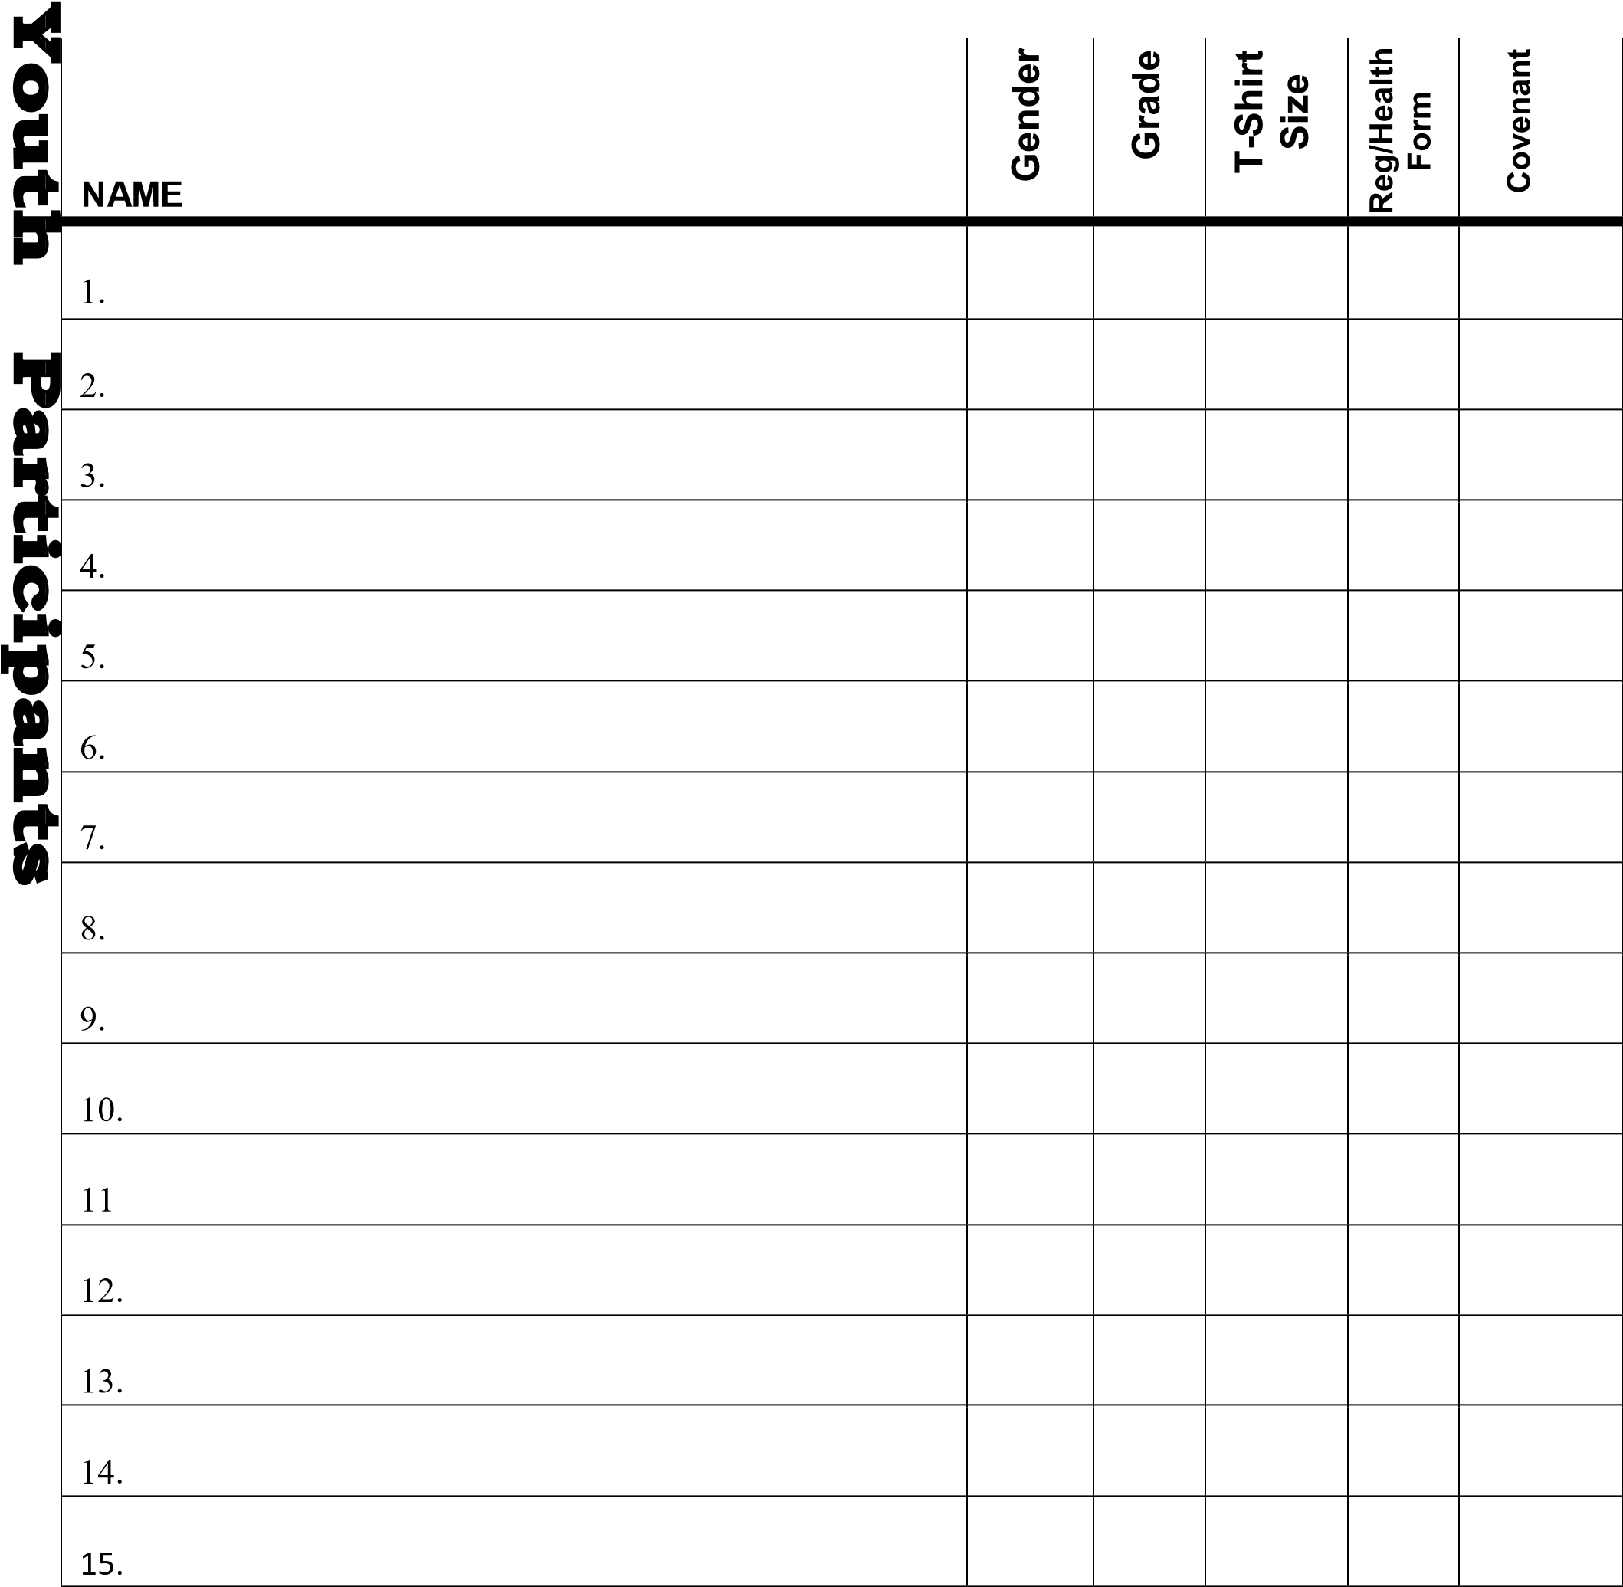
TOTAL NUMBER OF YOUTH PARTICIPANTS ______ CONTINUED ON BACK

Please PRINT the information indicated for each person attending.

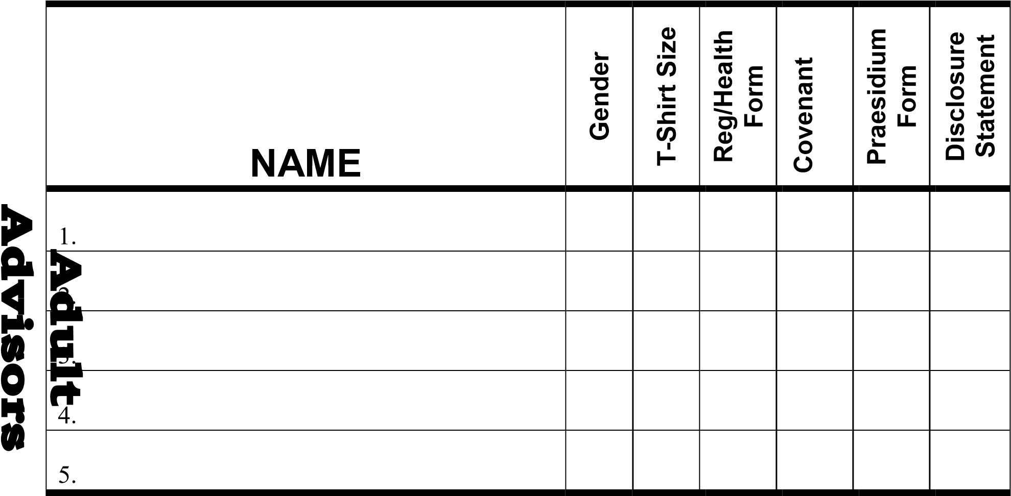

------------------------------------------------------------------------------------------------------------------

TOTAL NUMBER of Youth and Adult Registrations: X $140 =

TOTAL DUE =_______________

You are not fully registered until all your forms and payment are received. ALL adult background check forms (Praesidium) must be received before arrival or adult will not be allowed to attend the retreat and no refund will be given.

Make Check Payable to: MMSUCC

MAIL TOTAL DUE AND ALL REQUIRED FORMS TO:
Registrar -Youth Events
2659 Camp MoVal Road Union MO 63084

DISCLOSURE AND AUTHORIZATION FOR EMPLOYER TO ACCESS CONSUMER REPORTS
__________________________________________

DISCLOSURE

In connection with your application for employment with ____________________________________(including any independent contract for services and volunteer work) or when deciding whether to modify or continue your ongoing employment (if hired), ____________________________________may obtain a consumer report and/or an investigative consumer report on you from Praesidium, Inc. a consumer reporting agency, or from any third party, in strict compliance with both state and federal law. A consumer report is a communication of information by a consumer reporting agency bearing on your credit worthiness, credit standing, credit capacity, character, general reputation, personal characteristics, or mode of living which is used or expected to be used for purposes of serving as a factor in establishing your current and/or continuing eligibility for employment purposes. An investigative consumer report is a report obtained through personal interviews with individuals who may have knowledge of your character, general reputation, personal characteristics, or mode of living. The consumer reports or investigative consumer reports may contain information regarding your credit history (if applicable to position), criminal records, driving history records, education records, previous employment history, social security traces, military records, professional licensure records, drug testing, government records, and other types of background information. You further understand that these reports may contain information concerning the reasons for termination of past employment. You are hereby notified that you have the right to make a timely request for the nature and scope of any investigative consumer report. You are further notified that, prior to being denied employment based in whole or in part on information obtained in the consumer report, you will be provided a copy of the report, the name, address and telephone number of the consumer reporting agency and a description in writing of your rights under the Fair Credit Reporting Act. Inquiries to Praesidium, Inc. should be directed to Praesidium, Inc.; Consumer Disputes; P.O. Box 202002 Arlington, TX 76006. 1 (800) 743-6354.
MAINE AND NEW YORK APPLICANTS OR EMPLOYEES ONLY: You have the right to inspect and receive a copy of your investigate consumer report requested by ____________________________________ by contacting the consumer reporting agency identified directly above.

AUTHORIZATION
I hereby authorize, without reservation, the obtaining of consumer reports or investigative consumer reports by
____________________________________at any time after receipt of this authorization and throughout my employment, or service, if applicable. I further authorize and request, without reservation, any present or former employer, school, police department, state or federal agency, financial institution, division of motor vehicles, consumer reporting agencies, or other persons or agencies having knowledge about me to furnish Praesidium, Inc. or___________________________ _________with any and all background information in their possession regarding me, so that my employment qualifications may be evaluated and/or reassessed. I also agree that a fax or photocopy of this authorization with my signature should have the same authority as the voriginal.

By signing below, I certify: (1) that I have read and fully understand this disclosure and authorization; (2) that all of the information I am providing is true, complete, correct and accurate; and (3) that I have received the attached Summary of Your
Rights under the Fair Credit Reporting Act (15U.S.C.§1681etseq.).
NEW YORK APPLICANTS OR EMPLOYEES ONLY: By signing below, you acknowledge receipt of Article 23 A of the New York
Correction Law.

MINNESOTA AND OKLAHOMA APPLICANTS OR EMPLOYEES ONLY: Please check this box if you would like to receive a copy of a consumer if one is obtained by the Company.

CALIFORNIA APPLICANTS OR EMPLOYEES ONLY: By signing below, you also acknowledge receipt of the NOTICE REGARDING
BACKGROUND INVESTIGATION PURSUANT TO CALIFORNIA LAW. Please check this box if you would like to receive a copy of an investigativeconsumerreportorconsumercreditreportatnochargeifoneisobtainedbytheCompanywheneveryouhavea right to receive such a copy under California law.

The following is information required in order for____________________________________to obtain a complete consumer report:
FULL LEGAL NAME (First, Full Middle Name, Last Name)
STREET ADDRESS CITY STATE ZIP
COUNTIES YOU HAVE LIVED WITHIN THE PAST TEN YEARS (USE BACK OF SHEET IF YOU NEED ADDITIONAL SPACE)
(Circle any of the following states in which you have lived: CA, CO, DE, LA, MA, SD, VT, WV, WY)

SOCIAL SECURITY NUMBER DATE OF BIRTH*
DRIVER’S LICENSE NUMBER ISSUING STATE
OTHER OR FORMER NAMES (AKA, Maiden Names, Married Names, Sur names, Etc.)
________________________________________________________________________________________
CONSUMER’S SIGNATURE DATE
*This information will be used for background screening purposes only.

NOTICE REGARDING BACKGROUND INVESTIGATION PURSUANT TO CALIFORNIA LAW
____________________________________(them Company) in tends to obtain information about you for employment purposes from an investigative consumer reporting agency or consumer credit reporting agency. Thus, you can expect to be the subject of investigative consumer reports and consumer credit reports obtained for employment purposes. Such reports may include information about your character, general reputation, personal characteristics and mode of living. With respect to any investigative consumer report from an investigative consumer reporting agency (ICRA), the Company may investigate the information contained in your employment application and other background information about you, including but not limited to obtaining a criminal record report, verifying references, work history, your social security number, your educational achievements, licensure, and certifications, your driving record, and other information about you, and interviewing people who are knowledgeable about you. The results of this report may be used as a factor in making employment decisions. The source of any investigative consumer report (as that term is defined under California law) will be Praesidium, Inc.; P.O. Box 202002 Arlington, TX 76006. 1 (800) 743-6354.
The source of any credit report will be Praesidium, Inc.; P.O. Box 202002 Arlington, TX 76006. 1 (800) 743-6354. The Company agrees to provide you with a copy of an investigative consumer report when required to do so under California law. Under California Civil Code section 1786.22, you are entitled to find out from an ICRA what is in the ICRA’s file on you with proper identification, as follows: In person, by visual inspection of your file during normal business hours and on reasonable notice. You also may request a copy of the information in person. The ICRA may not charge you more than the actual copying costs for providing you with a copy of your file. A summary of all information contained in the ICRA’s file on you that is required to be provided by the California Civil Code will be provided to you via telephone, if you have made a written request, with proper identification, for telephone disclosure, and the toll charge, if any, for the telephone call is prepaid by or charged directly to you.
By requesting a copy to be sent to a specified addressee by certified mail. ICRAs complying with requests for certified mailings shall not be liable for disclosures to third parties caused by mishandling of mail after such mailings leave the ICRAs.
Proper Identification includes documents such as a valid driver’s license, social security account number, military identification card, and credit cards. Only if you cannot identify yourself with such information may the ICRA require additional information concerning your employment and personal or family history in order to verify your identity.
The ICRA will provide trained personnel to explain any information furnished to you and will provide a written explanation of any coded information contained in files maintained on you. This written explanation will be provided whenever a file is provided to you for visual inspection.
You may be accompanied by one other person of your choosing, who must furnish reasonable identification. An ICRA may require you to furnish a written statement granting permission to the ICRA to discuss your file in such person’s presence.
Camp MoVal Missouri Mid-South Conference United Church of Christ

BACKGROUND DISCLOSURE AND RELEASE

NAME ________________DATE __________________________
CHURCH NAME & LOCATION _____________________________________________________
I have been a member of this church since: ____________________________________________
I have been an employee or friend of this church since: ___________________________________
NOTE: Camp MoVal and the Missouri Mid-South Conference of the United Church of Christ will not deny participation to any applicant solely because the person has been convicted of a crime. However, the nature, date and circumstances of the offense as well as whether the offense is relevant to the duties of the position applied for may be considered.

- Please list every state in which you have lived, worked or been a student in the last seven years.
- I have never been convicted of, nor plead guilty or no contest to a criminal charge involving drugs, sexual misconduct, violence, theft or financial misconduct.
____True ____Not True
If not true, please briefly describe the nature of the crime(s), the date and place of conviction and the legal disposition of the case.

- No civil lawsuit alleging actual or attempted sexual discrimination, harassment, exploitation or misconduct; physical abuse; child abuse; or financial misconduct has ever resulted in a judgment being entered against me, been settled out of court, or been dismissed because the statute of limitations has expired.
____True ____Not True
If not true, give a short explanation of the lawsuit. Please indicate the date, nature and place of the incident leading to the lawsuit, where the lawsuit was filed, and the precise disposition of the lawsuit.

- I have never terminated my employment, professional credentials or service in a volunteer position, or had my employment, professional credentials or authorization to hold a volunteer position terminated, for reasons relating to allegations of actual or attempted sexual discrimination, harassment, exploitation, or misconduct; physical abuse; child abuse; or financial misconduct.
____True ____Not True
If not true, give a short explanation. Please indicate the date of termination, name, address and telephone number of employer or volunteer supervisor, and the nature of the incident(s) leading to your termination.

- With respect to my driving record, I have not had my license suspended or revoked within the last five years due to reckless driving or driving while intoxicated and/or under the influence of a controlled substance.
____True ____Not True
If not true, please briefly describe the nature of the crime(s), the date and place of conviction and the legal disposition of the case.

- Is there any fact or circumstance involving you or your background that would call into question you being entrusted with the responsibility of supervising or providing leadership for children and/or youth?
____Yes ____No
If yes, please provide a brief explanation.

The covenants between persons seeking to be involved in supervisory and/or leadership positions with children and/or youth and the organization through which they seek to serve require honesty, integrity, and truthfulness for the health of the church. To that end, I attest that the information set forth in this Disclosure Statement is true and complete. I understand that any misrepresentation or omission may be grounds for rejection of consideration for, or termination of, the position/role I am seeking to fill. I acknowledge that it is my duty to amend the responses and information I have provided, in a timely manner, if I come to know that the response or information was incorrect when given or, though accurate when given, the response or information is no longer accurate.
Beginning such relationships with an open exchange of relevant information builds the foundation for a continuing and healthy covenant between employees, authorized volunteers and the organization through which they seek to serve. To that end, I authorize Camp MoVal and the Missouri Mid-South Conference of the United Church of Christ (MMSC-UCC) and/or its agents to make inquiries regarding my character and qualification, including all statements I have set forth in this Disclosure Statement. I also authorize all entities, persons, former employees, supervisors, courts, law enforcement and other public agencies to respond to inquiries concerning me, to supply verification of the statements I have made, and to comment on and state opinions regarding my background, character and qualifications. To encourage such persons and entities to speak openly and responsibly, I hereby release them from all liability arising from their responses, comments, and statements made in good faith and without malice.
The MMSC-UCC process for screening persons seeking to be involved in supervisory and/or leadership positions with children/youth involves the sharing of information with those persons with oversight responsibilities. To that end, I authorize the MMSC-UCC and its agents to circulate, distribute and otherwise share information gathered in connection with this Disclosure Statement to such persons for these purposes. I understand that the MMSC-UCC will share with me information it has gathered about me if I request it to do so, unless I specifically waive that privilege.

Signature of Applicant:_____________________________________ Date____________

AFTER THE APPLICATION FORM IS COMPLETED, IT MUST BE SIGNED BY A RECOGNIZED REPRESENTATIVE OF THE CHURCH OR COMMUNITY LEADER.
The Applicant is (check one of the following):
____ an Active Member, Employee or Friend of a Church, or Clergy NOT currently serving a church -
The application is to be signed by a Pastor or Christian Education Director of the applicant
____ a Called Pastor - The application is to be signed by the Church Moderator or Council President;
____ an Interim Pastor or Supply - The application is to be signed by the appropriate Association Conference Minister;
____ a Conference Staff Person - The application is to be signed by Conference Minister.

CHURCH REPRESENTATIVE: Your signature indicates that you have reviewed this form for accuracy and completeness to the best of your knowledge, and that you have no reason to doubt this pers appropriateness to serve as leader with children or youth.

Signature of Church Representative________________________________________Date____________

Day Phone # _____________________________________

Name of Church or Community Representative (please print)____________________________________

Title ___________________________________ Evening Phone # _______________________________

